OUTPUTS FROM MESSAGEBOX:

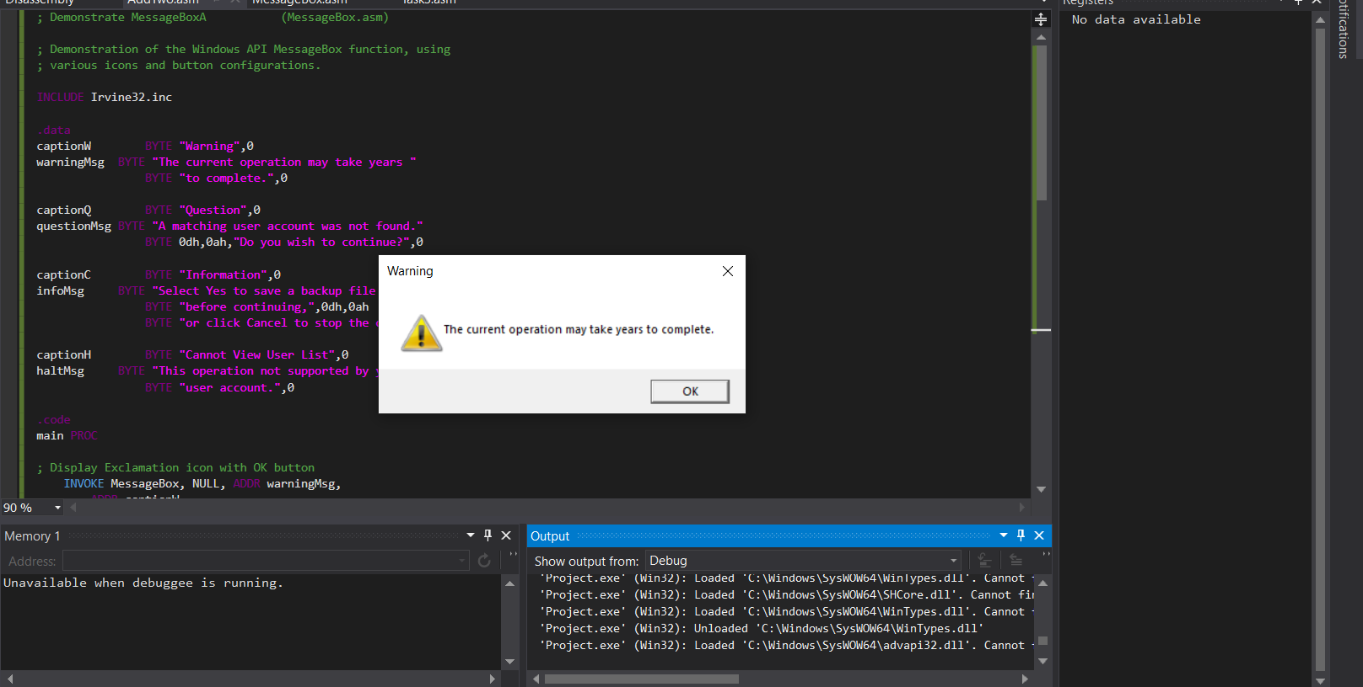

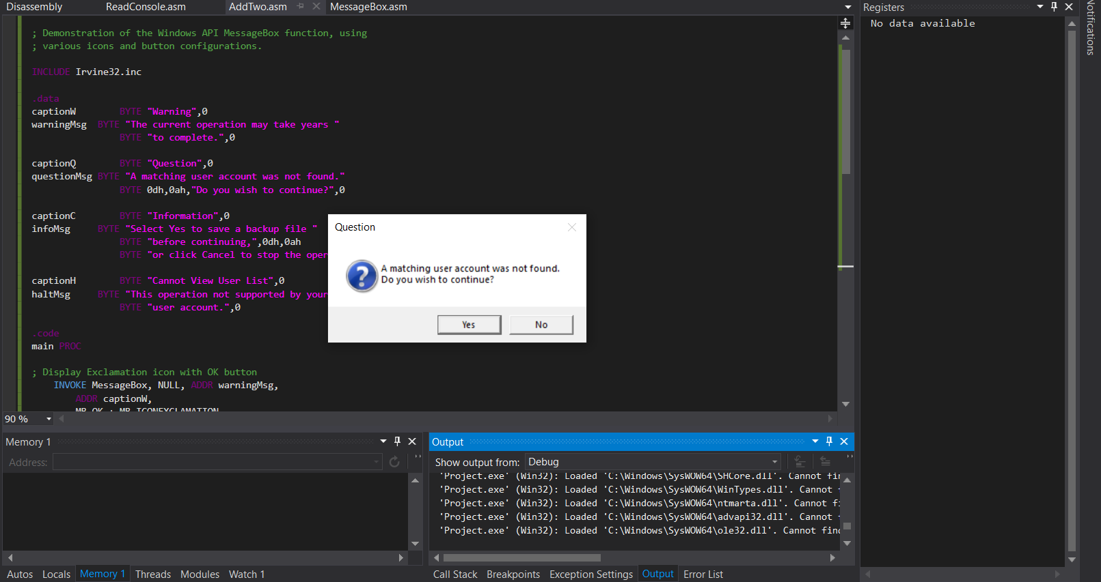

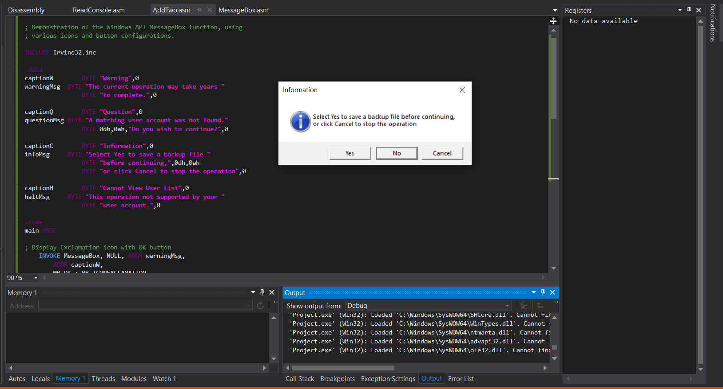

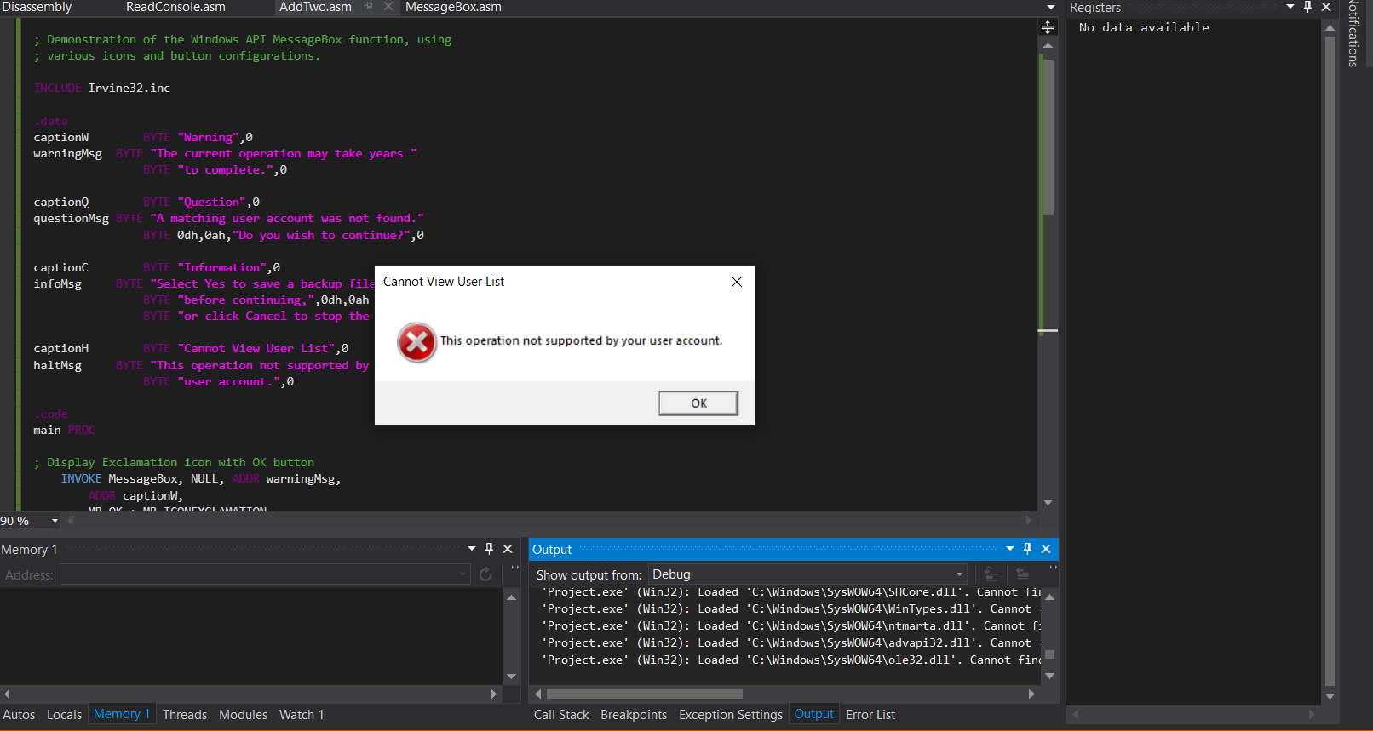

OUTPUT FROM READCONSOLE

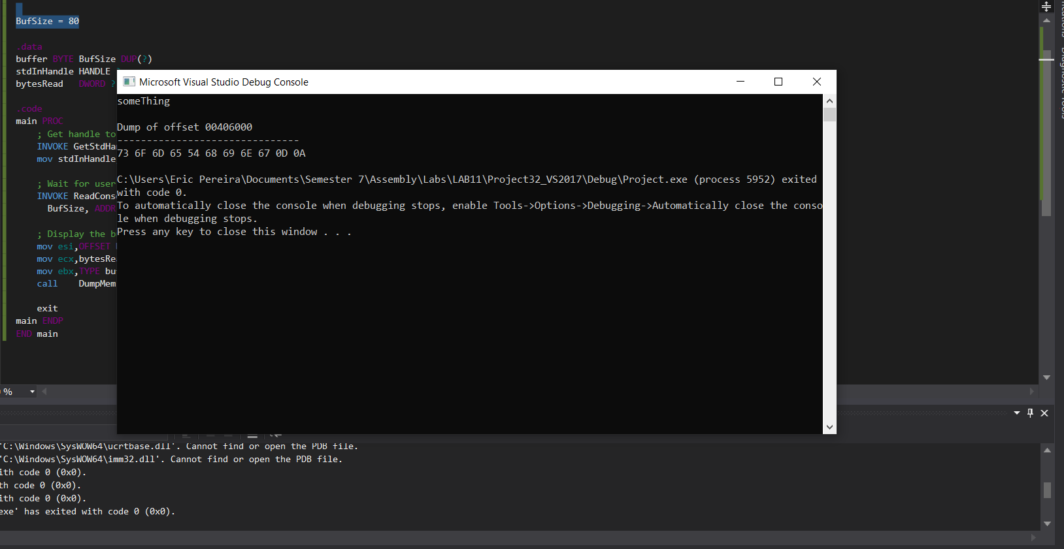

OUTPUT FROM CONSOLE1

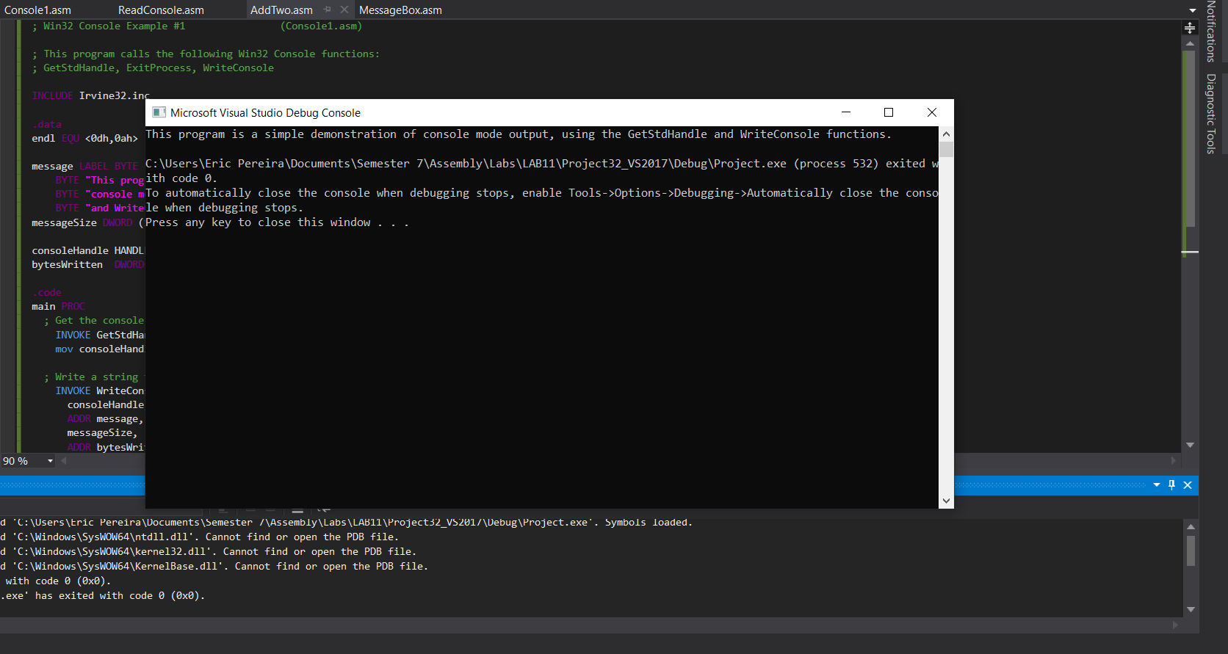

Task 4 source:

; Win32 Console Example #1 (Console1.asm)

; This program calls the following Win32 Console functions:

; GetStdHandle, ExitProcess, WriteConsole

INCLUDE Irvine32.inc

BufSize = 80

.data

endl EQU <0dh,0ah> ; end of line sequence

bytesReadfirst DWORD ?

bufferfirst BYTE BufSize DUP(?)

bufferfirstlength DWORD ($-bufferfirst)

bytesReadlast DWORD ?

bufferlast BYTE BufSize DUP(?)

bufferlastlength DWORD ($-bufferlast)

bytesReadage DWORD ?

bufferage BYTE BufSize DUP(?)

bufferagelength DWORD ($-bufferage)

bytesReadphone DWORD ?

bufferphone BYTE BufSize DUP(?)

bufferphonelength DWORD ($-bufferphone)

stdInHandle HANDLE ?

firstname LABEL BYTE

BYTE "input first name ", endl

firstnamesize DWORD ($-firstname)

lastname LABEL BYTE

BYTE "input last name ", endl

lastnamesize DWORD ($-lastname)

age LABEL BYTE

BYTE "input age ", endl

agesize DWORD ($-age)

phone LABEL BYTE

BYTE "input phone number ", endl

phonesize DWORD ($-phone)

someEnd label byte

Byte " ", endl

someEndSize DWORD ($-someEnd)

consoleHandle HANDLE 0 ; handle to standard output device

bytesWritten DWORD ? ; number of bytes written

bytesRead DWORD ?

.code

main PROC

; Get the console output handle:

INVOKE GetStdHandle, STD_OUTPUT_HANDLE

mov consoleHandle,eax

; Get handle to standard input

INVOKE GetStdHandle, STD_INPUT_HANDLE

mov stdInHandle,eax

; Write a string to the console:

INVOKE WriteConsole,

consoleHandle, ; console output handle

ADDR firstname, ; returns num bytes written

firstnamesize,

ADDR byteswritten,

0 ; not used

; Wait for user input

INVOKE ReadConsole, stdInHandle, ADDR bufferfirst,

BufSize, ADDR bytesRead, 0

INVOKE WriteConsole,

consoleHandle, ; console output handle

ADDR lastname, ; returns num bytes written

lastnamesize,

ADDR byteswritten,

0 ; not used

; Wait for user input

INVOKE ReadConsole, stdInHandle, ADDR bufferlast,

BufSize, ADDR bytesRead, 0

INVOKE WriteConsole,

consoleHandle, ; console output handle

ADDR age, ; returns num bytes written

agesize,

ADDR byteswritten,

0 ; not used

; Wait for user input

INVOKE ReadConsole, stdInHandle, ADDR bufferage,

BufSize, ADDR bytesRead, 0

INVOKE WriteConsole,

consoleHandle, ; console output handle

ADDR phone, ; returns num bytes written

phonesize,

ADDR byteswritten,

0

INVOKE ReadConsole, stdInHandle, ADDR bufferphone,

BufSize, ADDR bytesRead, 0

INVOKE WriteConsole,

consoleHandle,

ADDR someEnd,

someEndSize,

ADDR byteswritten,

0

INVOKE WriteConsole,

consoleHandle,

ADDR bufferfirst,

bufferfirstlength,

ADDR byteswritten,

0

INVOKE WriteConsole,

consoleHandle,

ADDR someEnd,

someEndSize,

ADDR byteswritten,

0

INVOKE WriteConsole,

consoleHandle, ; console output handle

ADDR bufferlast, ;lreturns num bytes written

bufferlastlength,

ADDR byteswritten,

0 ; not

INVOKE WriteConsole,

consoleHandle, ; console output handle

ADDR someEnd, ; returns num bytes written

someEndSize,

ADDR byteswritten,

0 ; not used

INVOKE WriteConsole,

consoleHandle, ; console output handle

ADDR bufferage, ; returns num bytes written

bufferagelength,

ADDR byteswritten,

0 ; not used

INVOKE WriteConsole,

consoleHandle, ; console output handle

ADDR someEnd, ; returns num bytes written

someEndSize,

ADDR byteswritten,

0 ; not used

INVOKE WriteConsole,

consoleHandle, ; console output handle

ADDR bufferphone, ; returns num bytes written

bufferphonelength,

ADDR byteswritten,

0 ; not used

INVOKE WriteConsole,

consoleHandle, ; console output handle

ADDR someEnd, ; returns num bytes written

someEndSize,

ADDR byteswritten,

0 ; not used

INVOKE ExitProcess,0

main ENDP

END main

Task 4 console:

